**Configuration Sheet For**

**Datalogic PM9500 Full Settings**

1. **Set Default**



1. **Linking the Reader**



1. **Set Date Time**



1. **Other Config Codes**





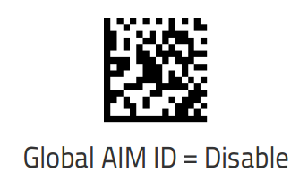





1. **SET OPOS Mode USB-OEM**



Make sure you installed Datalogic OPOS Drivers before scanning this barcode.

Drivers available from this Link (You need opos drivers):

<http://www.datalogic.com/eng/products/automatic-data-capture/industrial-handheld-scanners/powerscan-pm9500-dpm-evo-pd-631.html#download>