**Configuration Sheet For**

**Datalogic PM9500 Full Settings**

1. **Set Default**



1. **Linking the Reader**



1. **Set Date Time**





**See next Page for Keypad for numbers Barcodes**





1. **Other Config Codes**





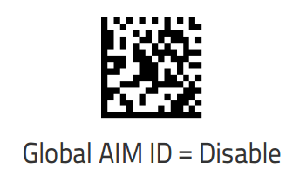



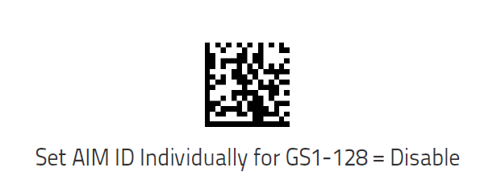



1. **SET USB-COM Serial**



1. **Set Prefix**





 

**MUST SCAN Enter /Exit Programming Mode Twice**





1. **Set Suffix**





 

 

**MUST SCAN Enter /Exit Programming Mode Twice**

 