**Configuration Sheet**

**For**

**Honeywell Granit 1911i OPOS Mode**

1. **Restore defaults**

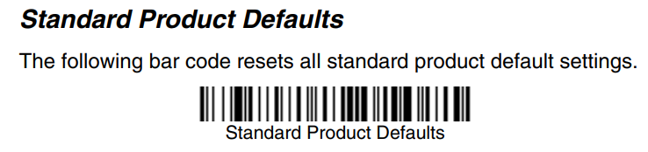

1. **USB OPOS**

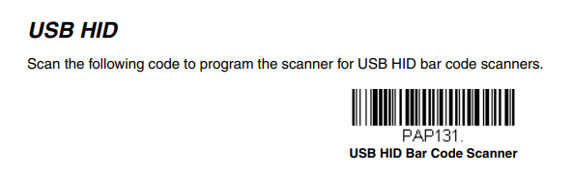

1. **No Terminator**

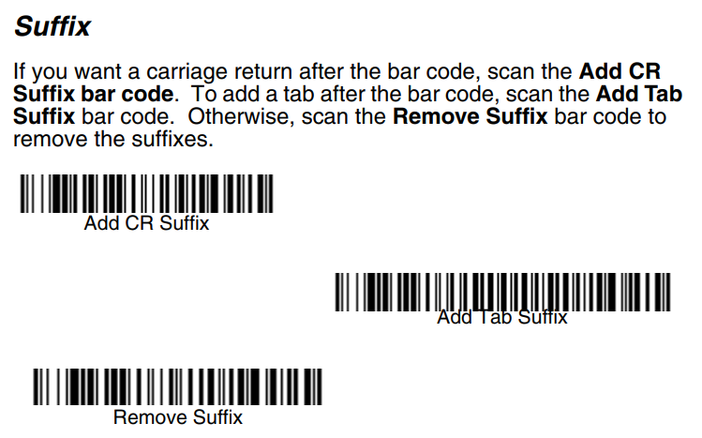

1. **Triger Or Presentation**

