**Configuration Sheet For OPOS Mode**

**Newland NLS-FR40X0**

1. **Configure OPOS**

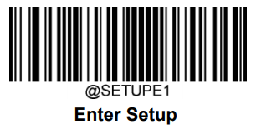

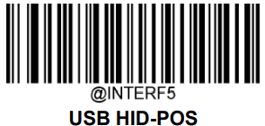

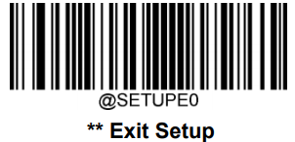

**Wait to finish Beeping**