**Configuration Sheet**

**For**

**Zebra Motorola Symbol Zebra DS3578**

1. **Restore Defaults**



1. **USB OPOS**



1. **No Headers or Terminators**



1. **Disable Transmit Code ID Character**



1. **Enable Interleave 2 of 5**

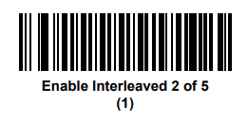

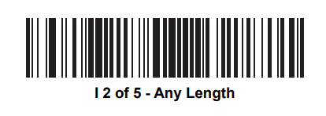

1. **Unpair/disconnect**



**Then Scan the Pair Barcode in the Cradle and place the Scanner in cradle and Wait for 10 seconds**