**Configuration Sheet**

**For**

**Zebra Motorola Symbol Zebra DS3578**

**1. Restore Defaults**

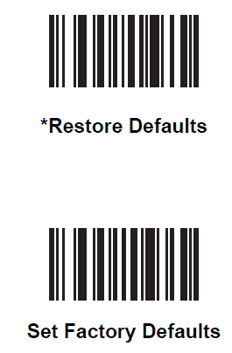

**2. USB OPOS**

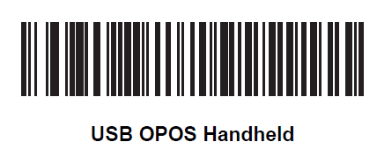

**3. No Headers or Terminators**

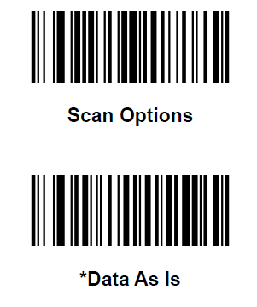

**4. Disable Transmit Code ID Character**

