RACM Document for MRL

Table of Contents

Initial Configuration: 2

1. Database Configuration XML: 2

i. Test Settings: 2

ii. Prod Settings: 2

2. Database Configuration Manually: 2

Setup Label Printing: 3

1. ExLabel Installation & Setup 3

2. Setup Label Printing: 4

3. Setup Printer: 6

Default Login Credentials: 7

Auditing Data: 7

Back End Auditing: 7

RACM Audit Report: 7

Add Domain Users: 8

RACM Mobile Configuration: 8

Bluetooth Setup: 8

Honeywell Scanner Settings: 8

RACM Setup: 9

Troubleshooting: 9

Bluetooth Connection Failure: 9

# Initial Configuration:

## Database Configuration XML:

**NOTE:** “ProgramData” folder is hidden.

### Test Settings:

* + 1. **Download** zip folder from this web address. <https://updates.existco.com.au/MRL/Test%20Settings/Existco%20Pty%20Ltd.zip>
    2. **Unzip** into this location: “C:\ProgramData\”

### Prod Settings:

* + 1. **Download** zip folder from this web address. <https://updates.existco.com.au/MRL/Prod%20Settings/Existco%20Pty%20Ltd.zip>
    2. **Unzip** into this location: “C:\ProgramData\”
  1. **Open** Roshtek Asset Consumable Manager to complete setup.
  2. **NOTE:** Step two: “Database Configuration Manually” is no longer necessary.
  3. **NOTE:** Make sure to setup Full Permissions for the “C:\ProgramData\Existco Pty Ltd”

## Database Configuration Manually:

* 1. After installation **Left Click** the **Roshtek Asset Consumable Manager desktop icon**.
  2. The initial database configuration form will appear.

* 1. **Select** **Configure Database Settings** and then **Left Click** the **Ok Button**.
  2. A password prompt will appear, Type the password “roshtek”.

* 1. The application will attempt to connect to the default database. Ignore the prompted error message.
  2. A database configuration form will appear. **Enter** the **SQL Database details**.
  3. **Select** **Windows Authentication** from the **Authentication drop-down**.

* 1. **Left Click** **Test**, if successful. **Left Click** the **Save/Exit Button**.

* 1. **Left Click** the **Ok Button** and the application will restart.
  2. **NOTE:** Make sure to setup Full Permissions for the “C:\ProgramData\Existco Pty Ltd”

# Setup Label Printing:

## ExLabel Installation & Setup

* 1. **Download** **ExLabel** from the following link. <https://updates.existco.com.au/AdvanceInstaller/ExLabel/Existco.ExLabel.Setup.exe>
  2. **Install** **ExLabel**.
  3. **Left Click** **Help** and **Select** **About ExLabel**.

* 1. **Left Click** **Change License Key** and **Enter** **MRL License Key**.

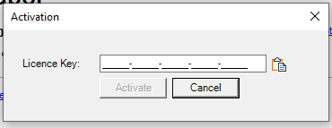

* 1. **Left Click** **Activate**.

## Setup Label Printing:

* 1. Download the Asset Label files:
     1. <https://updates.existco.com.au/MRL/Labels.zip>
     2. Unzip into directory “C:\ProgramData\Existco Pty Ltd\Roshtek Asset Consumable Manager”
  2. **Open** **Roshtek Asset Conumsable Manager**.
  3. **Left Click** **Options/Label Printing/Activate Label Printing**.



* 1. **Enter** password **“activate”.**

* 1. **Left Click** the **Yes Button**.

* 1. **Navigate** to the **ExLabel Program Files Location**: “C:\Program Files (x86)\Existco Pty Ltd\ExLabel\Existco.ExLabel.exe”.
  2. **Left Click** the **Open Button**.

* 1. **Navigate** to the **Asset Label file**: “C:\ProgramData\Existco Pty Ltd\Roshtek Asset Consumable Manager\Labels\AssetLabel.etl”.

* 1. **Left Click** the **Open Button.**

* 1. **Left Click** the **Cancel Button** for **Contact Label**.

## Setup Printer:

* 1. **Open** **Asset Label file**: “C:\ProgramData\Existco Pty Ltd\Roshtek Asset Consumable Manager\Labels”

* 1. **Left Click** the **Printer Icon**.

* 1. **Select** your **printer** from the **drop down**.
  2. **Uncheck** **Print as Graphic**.
  3. **Select** ”ZPL” for **Zebra Printers**.

* 1. **Left Click** **Print** to save and test.

# Default Login Credentials:

Default login:

Username: admin.

Password: admin.

# Auditing Data:

## Back End Auditing:

SQL Audit: Run the below SQL script to track user transactions.

DECLARE @StartDate AS DATETIME = '2023-01-01';

DECLARE @EndDate AS DATETIME = '2023-08-01';

SELECT t.[TransactionDate], a.[AssetNo], t.[TransactionComments] AS [Comment], tt.[TransactionTypeDescription] AS [Type], u.[UserName] FROM [eaTransaction] t

INNER JOIN [eaTransactionTypes] tt ON tt.[TransactionTypeID] = t.[TransactionTypeID]

LEFT JOIN [xUsers] u ON u.[UserID] = t.[UserID]

LEFT JOIN [eaAsset] a ON a.[AssetID] = t.[AssetID]

WHERE t.[TransactionDate] BETWEEN @StartDate AND @EndDate

ORDER BY t.[TransactionDate] DESC

## RACM Audit Report:

1. **Open** Reports/Audit Reports
2. **Select** the start and end dates
3. **Filter** by location if necessary and **Select** the All radio button.
4. **Left Click** the **Open Button**.

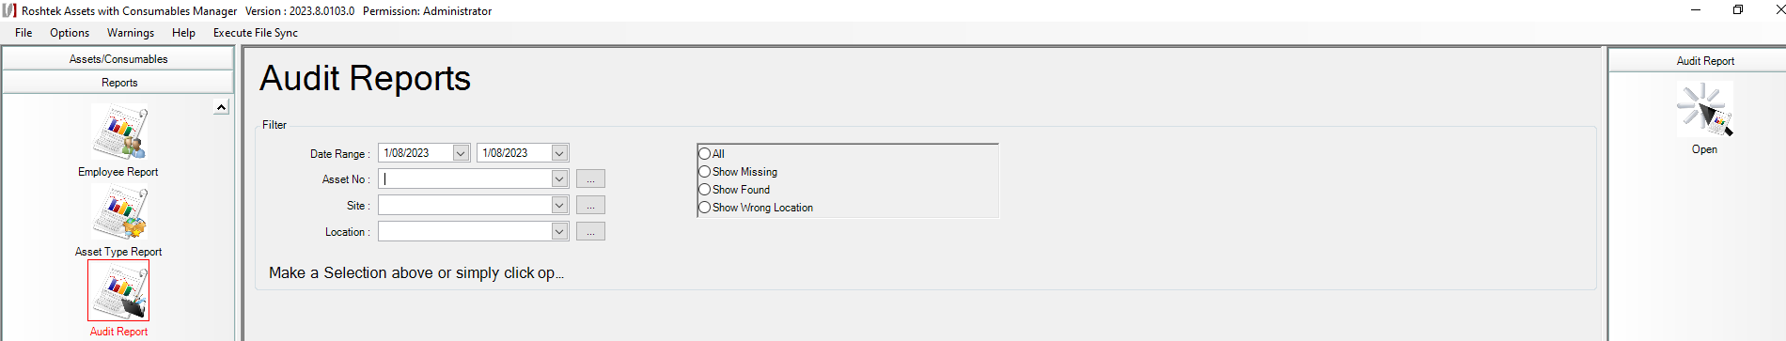

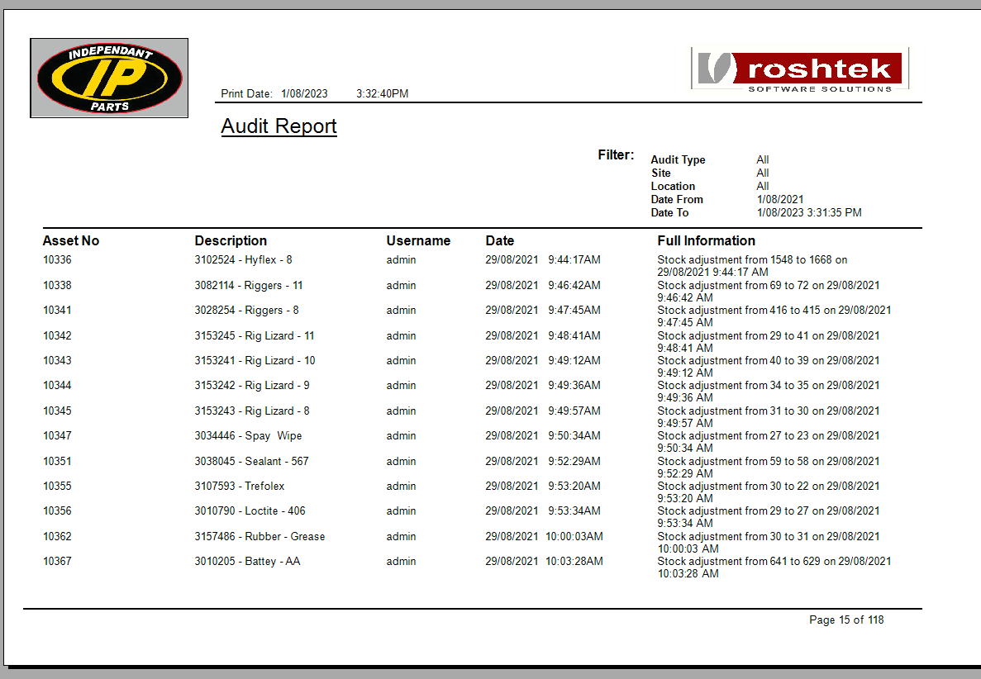

# Add Domain Users:

1. **Open** **Roshtek Asset Consumable Manager.**
2. **Go** to **Administration/Users.**
3. **Left Click** the **Add Button**.
4. **Enter** the **username** and **password** for the mobile scanner.
5. **Set** **privilege level** from the dropdown.
6. **Enter** the **domain user**. E.g. PIHA-CSI\Adam.
7. **Left Click** the **Save/Exit Button.**

# RACM Mobile Configuration:

## Bluetooth Setup:

1. On mobile scanner **go** to **device settings**.
2. **Select** **Connected Devices**.
3. On the touchscreen **go** to the **Bluetooth settings**.
4. **Pair** new device on the mobile scanner, by **selecting** the **touchscreens name** in the list.
5. On the touchscreen **accept** the **pairing**.

## Honeywell Scanner Settings:

1. On mobile scanner **go** to **device settings**.
2. **Select** **Honeywell Settings**.
3. **Navigate** to **Scanning/Internal Scanner/Default Profile/Data Processing Settings.**
4. **Untick** **Wedge**.

## RACM Setup:

1. **Open** **RACM** on the **mobile scanner**.
2. **Tap** the **three-dot button** in the top right corner.
3. **Select** **Maintenance** from the list.
4. **Set** **Sync Method** to **Bluetooth**.
5. **Tap** the **Bluetooth Device selector** and **select** the **touchscreens name** from the list.
6. **Select** **Honeywell** as the **Device Type**.
7. **Set** **Contact Label** to **“Asset No”.**
8. **Set** **Contact Name Label** to **“Asset Name”.**
9. **Set** **Asset Label** to **“Item No”.**
10. **Set** **Capitalize Entry** to ticked.
11. **Tap** the **Save Button**.

# Troubleshooting:

## Bluetooth Connection Failure:

If the connection between the mobile scanner and touchscreen fails. Make sure both devices are Bluetooth paired with each other. On RACM Desktop, left click on the Reset Sync button to reestablish the Bluetooth link.