**Roshtek Asset Consumable Manager Mobile - User Guide**

**For the Roshtek Asset Consumable Manager Mobile Application**

**Documentation**

Copyright © 2023 Existco Pty Ltd, All Rights Reserved.

Copyright © 2023 Existco Pty Ltd. All rights reserved. Material in this publication may not be reproduced or transmitted in any form or by any means, without prior written permission. Requests for that permission should be directed to:

Existco Pty Ltd

10 Weir Rd

Malaga, WA, 6090

+61 8 9227 0088

The contents of this publication are believed to be accurate. However, responsibility cannot be assumed for the information contained herein, and the consequences resulting from the use thereof. Material in this publication is subject to change without notice.

This Implementation Strategy and the computer software it describes are designed to provide accurate and authoritative information in regard to the subject matter covered. They are distributed with the understanding that the publisher is not engaged in rendering legal, accounting, or other professional service. If legal advice or other expert assistance is required, the services of a competent professional person should be sought.

While Existco will make a reasonable effort to ensure deployment does not interfere with day-to-day operations at the client premises, it is ultimately the client’s responsibility to ensure backups are in place and are viable in the event of a catastrophic failure. In addition, Existco assumes no responsibility for failures outside the scope of this deployment.

**Document Control**

|  |  |  |
| --- | --- | --- |
| **Date** | **Change** | **Author** |
| 2023-02-23 | Initial document | Sami Pathan |
|  |  |  |
|  |  |  |
|  |  |  |
|  |  |  |
|  |  |  |

Table of Contents

1. Installation 5

2. Login 7

3. Sync Resources 7

4. Check In 9

5. Check Out 12

6. Move 15

7. Issue Parts 18

8. Settings 22

9. Check for updates 24

10. LogOut 26

11. Exit 27

12. Vendor Contact Details 28

# Installation

* 1. **Aim** **mobile device** at the supplied **QR Code.**

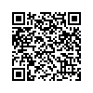

* 1. **Tap** or **Press** the **Scan Button** until the **device beeps.**
  2. Or **Copy and Paste** the following link into your web browser.

[**https://updates.existco.com.au/Android/downloads/latest/com.existco.racm.apk**](https://updates.existco.com.au/Android/downloads/latest/com.existco.racm.apk)

* 1. **Open** the **supplied link** and **Download** the **apk file**.
  2. **Install** **apk file** by following the **prompt.** and **allowing** install from **unknown source**.
  3. Once installed **press** **YES** when **Permission Required dialog box** is open.

* 1. **Scroll down** until you find **Install unknown apps** and tap on that**.**

* 1. **Tap** on **switch** **against Allow from this source** to enable the feature.

* 1. **Go** back until you reach to login page

# Login

* 1. **Open** **RACM** Application
  2. **Enter admin** in **username** and **admin** in **password** text boxes
  3. **Press LOGON** button

# Sync Resources

* 1. **Connect** the **device** to the **computer** via the **data cable** which is provided by Existco.
  2. **Login** into the **RACM** **application** to go to the **main page**
  3. **Press** **SYNC RESOURCES** button

* 1. Check all the checkboxes and press on SYNC DATA button

* 1. **Wait** till all data is synced successfully.

# Check In

* 1. **Login** into the **RACM** **application** to go to the **main page**
  2. **Press** **Check In** button

* 1. **Scan** an **item** that is being checked in.

* 1. If the item is not consumable, then it will be checked in straight away. If it is consumable, then **enter** **Quantity** and **Location**

* 1. **Use** **keypad** to **enter** **quantity** or **scan** the same **item** and the **quantity** will increment by 1
  2. **Scan** different **item** or **press** **CHECKIN** **button** to check in the **item**.

# Check Out

* 1. **Login** into the **RACM** **application** to go to the **main page**
  2. **Press** **Check Out** button

* 1. **Enter due date** first and then **do** the following
  2. **Scan** an **item** that is being checked out.
  3. **Scan** the **person** who the item is being checked out to.

* 1. If the item is not consumable, then it will be checked out straight away. If it is consumable, then **enter** **Quantity** and **Location**

* 1. **Use** **keypad** to **enter** **quantity** or **scan** the same **item** and the **quantity** will increment by 1
  2. **Scan** different **item** or **press** **CHECKOUT** **button** to check out the **item**.

# Move

* 1. **Login** into the **RACM** **application** to go to the **main page**
  2. **Press** **Move** button

* 1. **Scan** an **item** that is being moved.

* 1. **Enter** all **details** where the **item** is moving to

* 1. **Select** **location** **where** the **item** is moving from
  2. **Use** **keypad** to **enter** **quantity** or **scan** the same **item** and the **quantity** will increment by 1

* 1. **Scan** different **item** or **press** **Move** **button** to move out the **item**.

# Issue Parts

* 1. **Login** into the **RACM** **application** to go to the **main page**
  2. **Press** **Issue Parts** button

* 1. **Enter or Scan** a **Job No**
  2. **Enter or scan** the asset that is consuming parts.

* 1. **Scan** or **enter** an **item** **number** that is being consumed.

* 1. If the item is not consumable, then it will be checked out straight away. If it is consumable, then **enter** **Quantity** and **Location**

* 1. **Use** **keypad** to **enter** **quantity** or **scan** the same **item** and the **quantity** will increment by 1
  2. **Scan** different **item** or **press** **Save** **button** to check out the **item**.

# Settings

* 1. **Login** into the **RACM** **application** to go to the **main page**
  2. **Press** SETTINGS button

* 1. **Select** all the **options** listed in the page and **Press SAVE** button

# Check for updates

* 1. **Open** and **run** the **application**
  2. **Click** on three **vertical dots** located on top right corner to open a **menu**

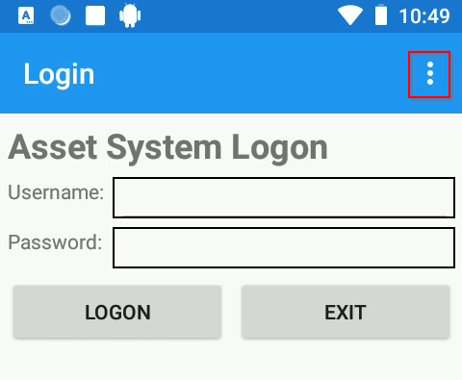

* 1. **Select** **Check or updates** option from the list

* 1. Follow the prompts to install the latest updates.

# LogOut

* 1. **Login** into the **RACM** **application**
  2. Go to the **Main Page** If not on the **Main Page**
  3. **Press LOG OUT** button

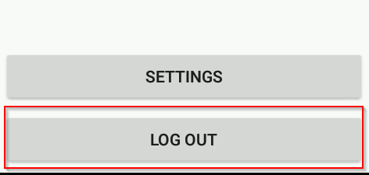

# Exit

* 1. **Repeat Step 9 to log out**
  2. **Press EXIT** button

# Vendor Contact Details

Existco Pty Ltd

10 Weir Road

Malaga, WA, 6090

Phone: +61 8 9227 0088

Fax: +61 8 9227 0066

ABN: 48 108 989 180

E-mail: [support@existco.com.au](mailto:support@existco.com.au)