|  |
| --- |
| EXISTCO pty ltd. |
| USER MANUAL |
| Wasp Addons |
| Version 1.0 |
| **Nhat Le** |
| **08/02/2013** |

|  |
| --- |
|  |

Table of Contents

I. Login Menu 2

II. Configuration 2

III. Do Check In 3

IV. Do Check Out 5

1. Check out an Asset 5

2. Check out an Inventory Item 6

3. View Report 8

V. Asset Outstanding Report 9

# Login Menu

* **Run** ***Wasp Addons*** application
* Login menu appears as below:

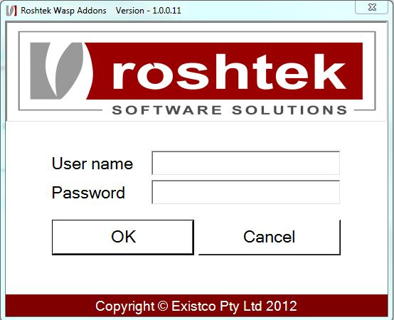

* **Enter** ***Username***
* **Click** ***OK*** button

# Configuration

* **Select** ***Windows->Configurations*** menu ***from*** the ***Main Menu***
* **Enter *Password*** to access ***Configurations*** form. ***Default Password*** is ***WaspAddons***

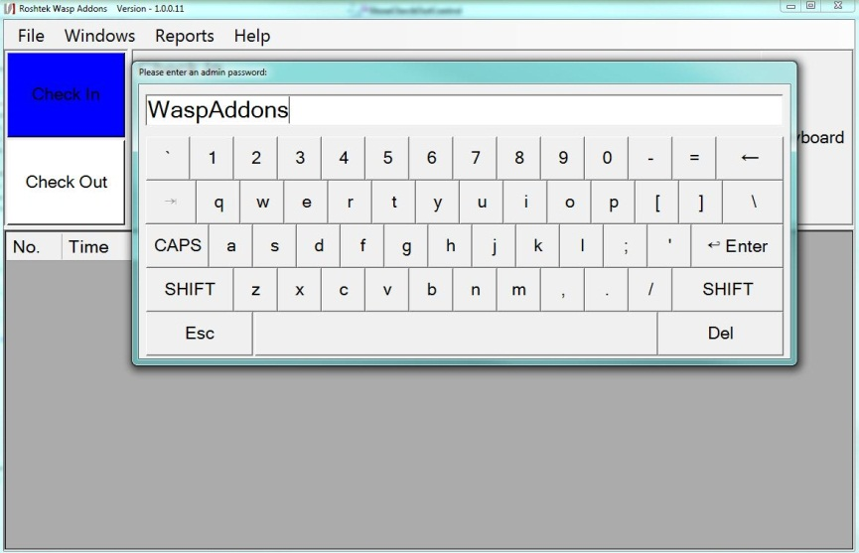

* ***Configuration form*** appears

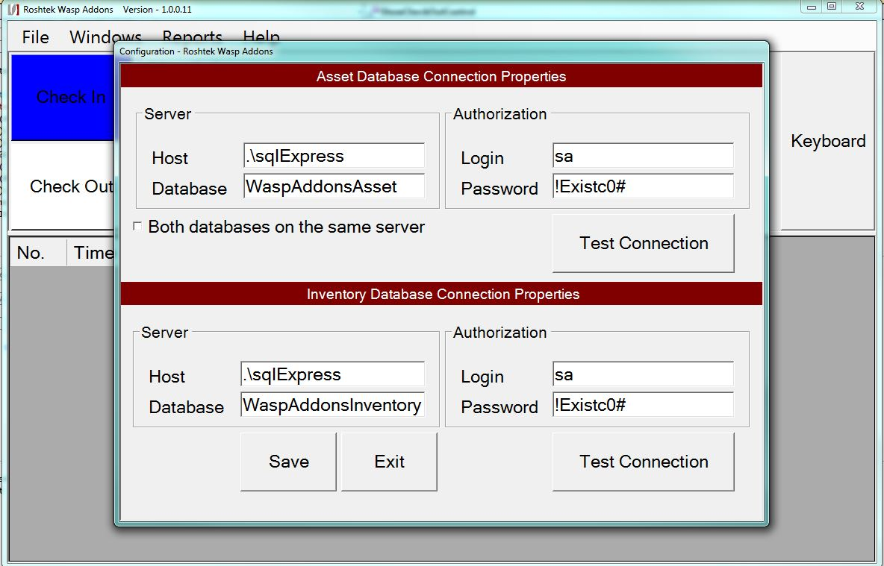

* **Enter *Connection Properties*** for ***Asset*** and ***Inventory database***
* **Click *Save*** button to Save data

# Do Check In

* **Click *Check In button*** from ***Left Menu***

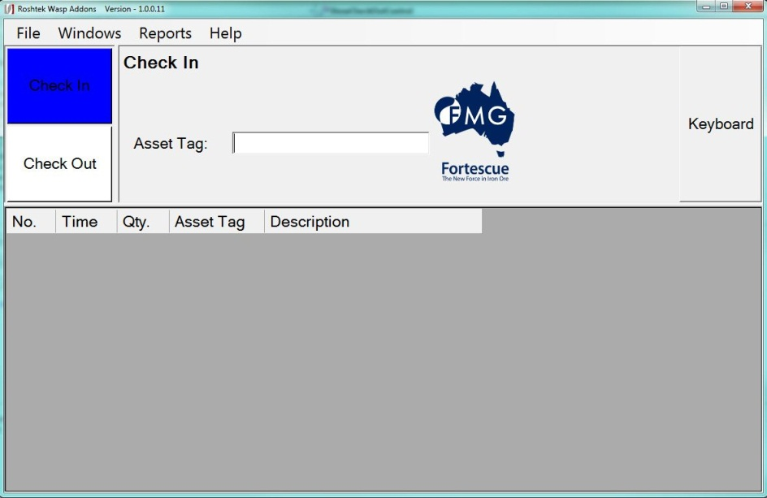

* **Scan *Asset Tag*** or**Click *Keyboard button*** to ***manually enter Asset Tag***

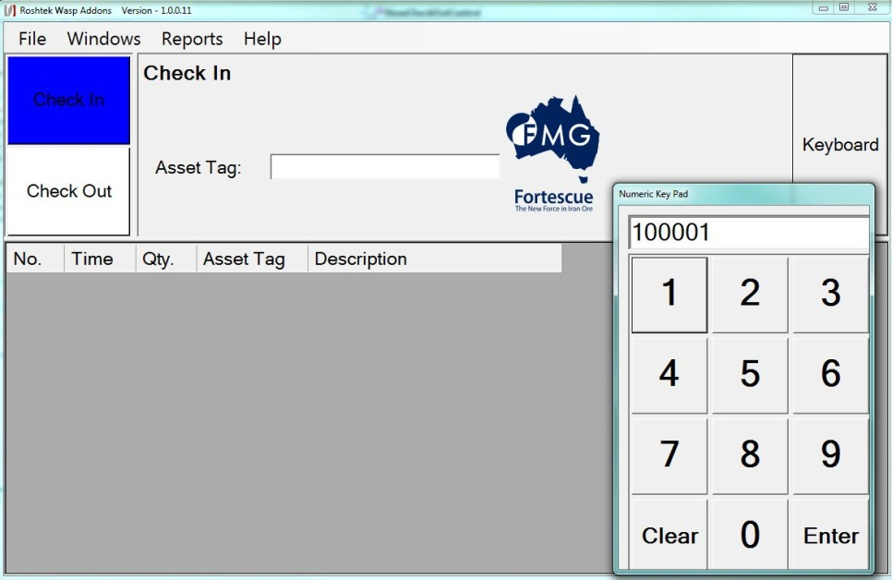

* ***Data* saved*. Repeat steps above to* scan/enter *other items***

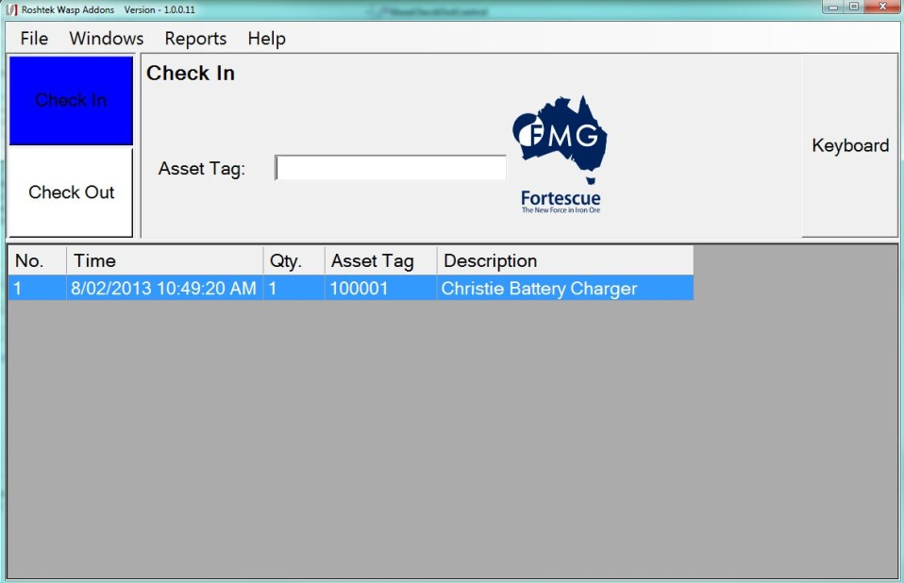

# Do Check Out

* **Click *Check Out button*** from ***Left Menu***

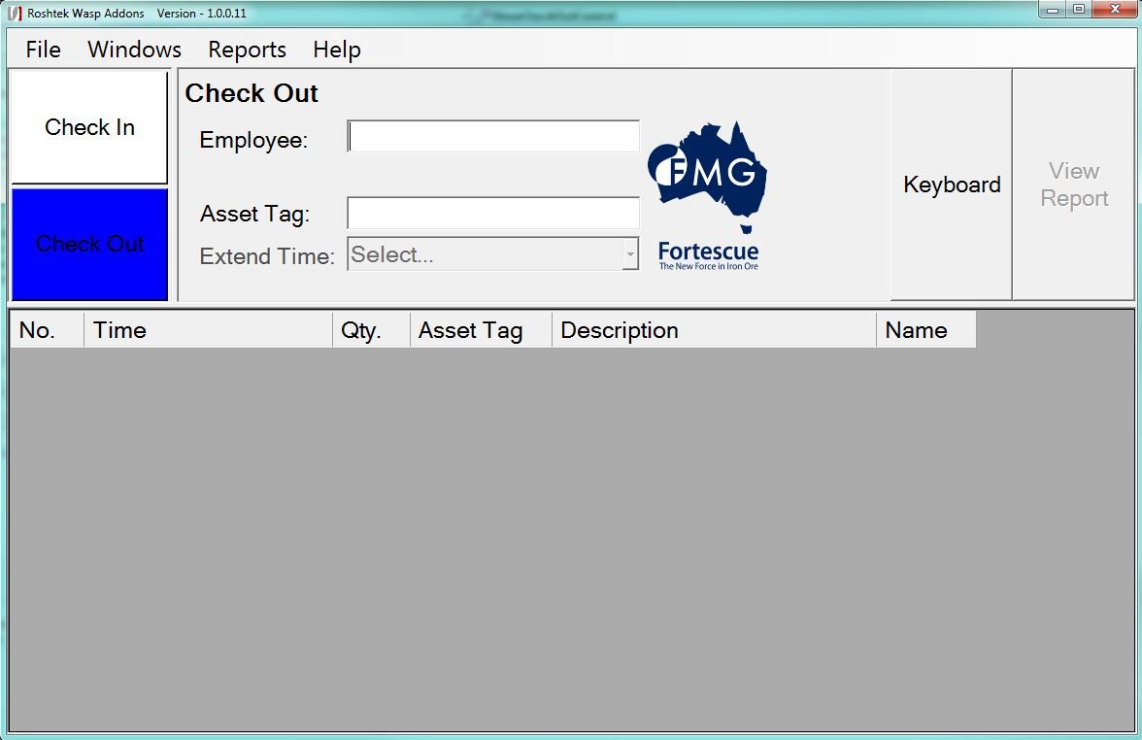

## Check out an Asset

* **Scan/Enter *Employee*** or ***Customer Barcode Number***
* **Scan *Asset Tag*** or**Click *Keyboard button*** to ***manually enter Asset Tag***

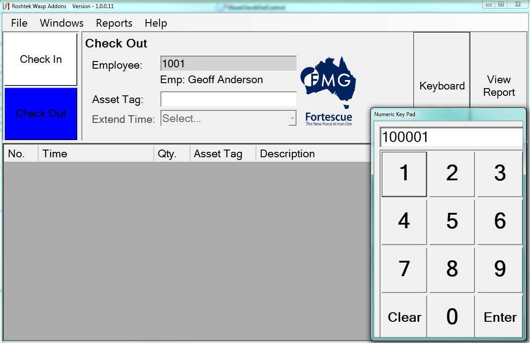

* ***Data* saved**

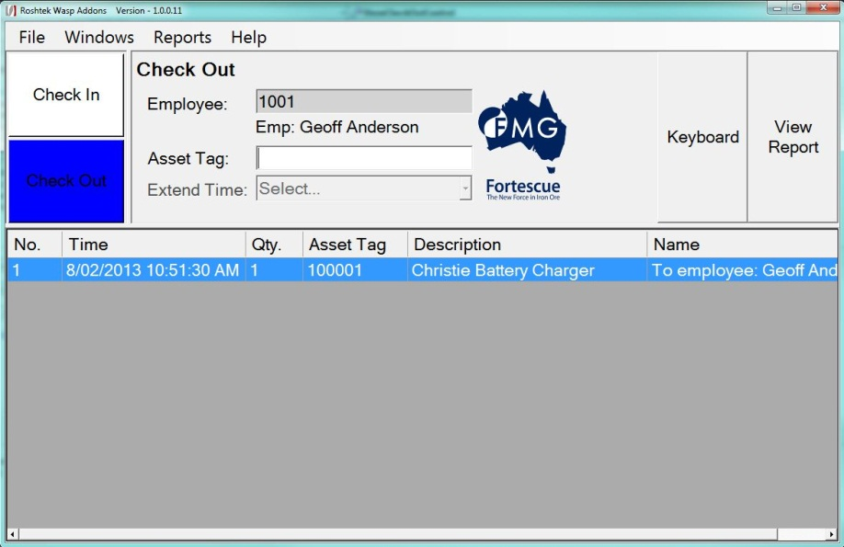

## Check out an Inventory Item

* **Scan/Enter *Customer Barcode Number***

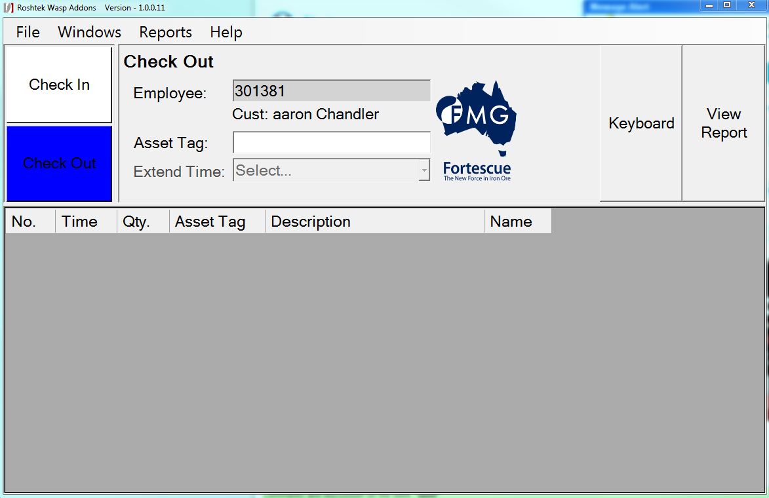

* **Scan *Asset Tag*** or**Click *Keyboard button*** to ***manually enter Asset Tag***

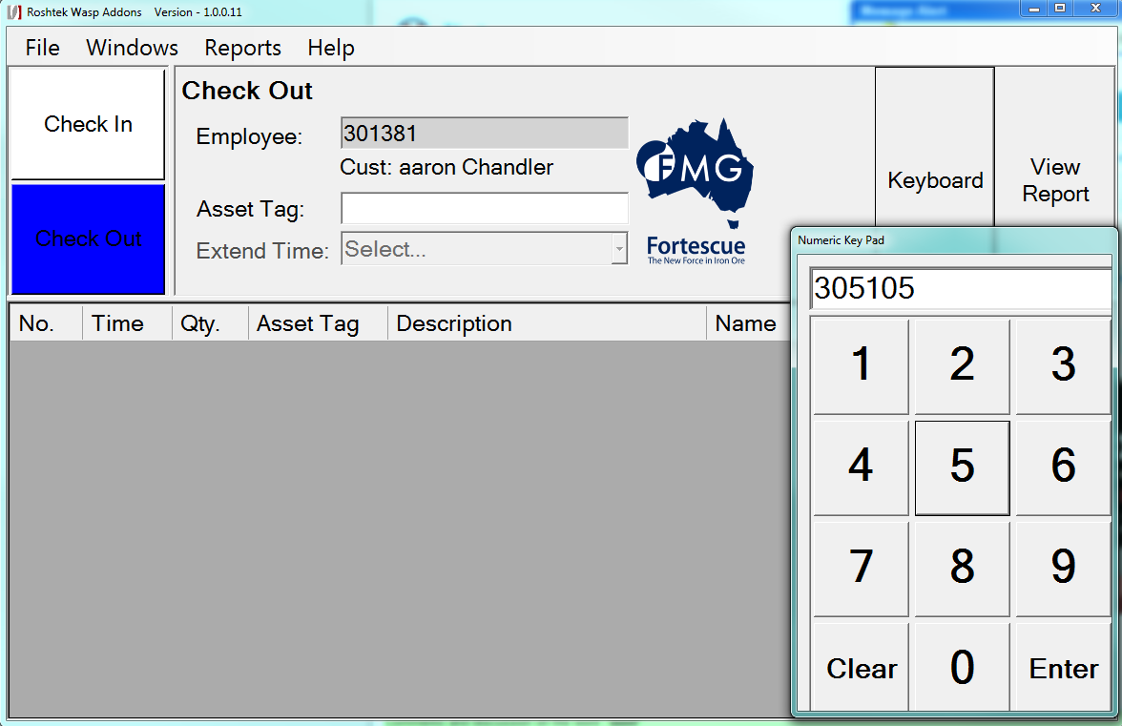

* ***A quantity form will* popup**

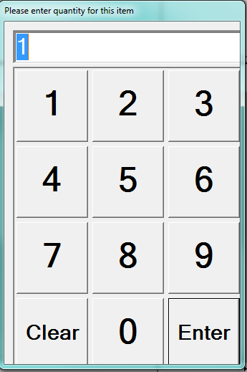

* ***If an inventory item* is scanned *in sequence, the quantity*** will be automatically ***increased by* 1**
* **Click *Enter*** to ***save data.***

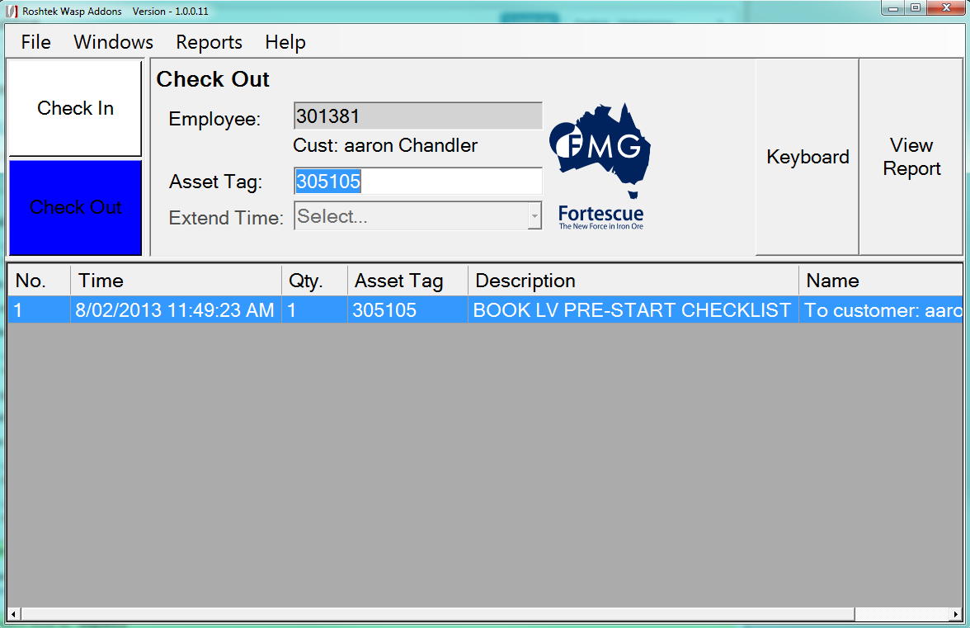

## View Report

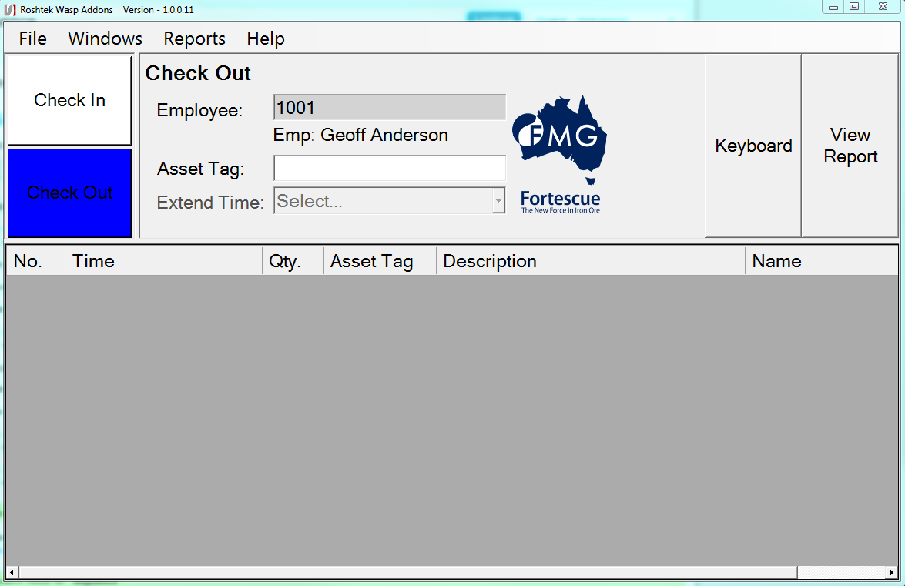

* **Scan/Enter *Employee*** or ***Customer Barcode Number***
* **Click *View Report*** button
* ***Report* is showed**

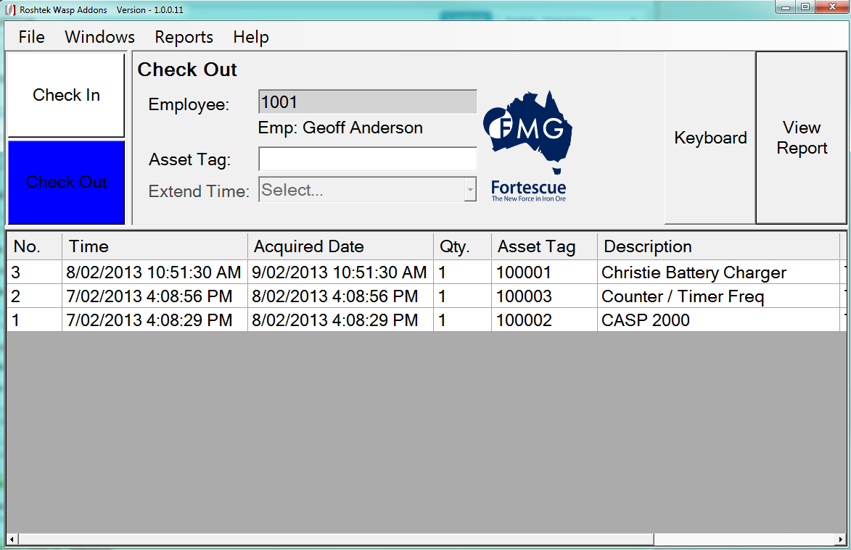

# Asset Outstanding Report

* **Select** ***Reports->Asset Outstanding Report*** menu ***from*** the ***Main Menu***

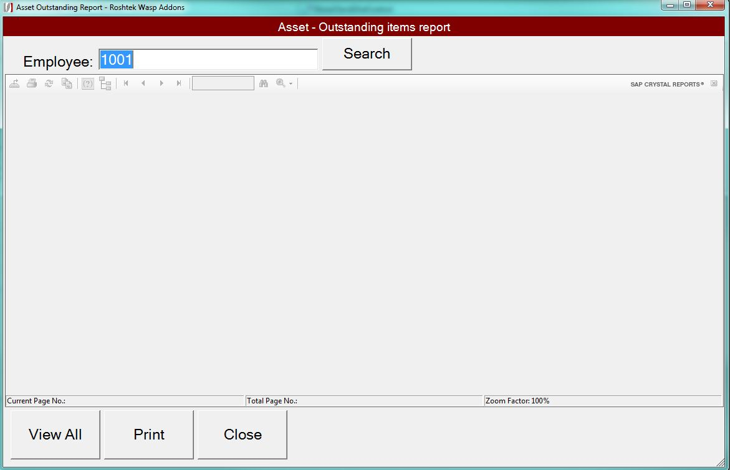

* **Enter** ***Employee Number*** then ***Click Search button*** to ***View report*** by ***Employee***
* ***Or* Click  *Search button*** to ***View reports*** by ***All Employee***
* ***Report* isgenerated**

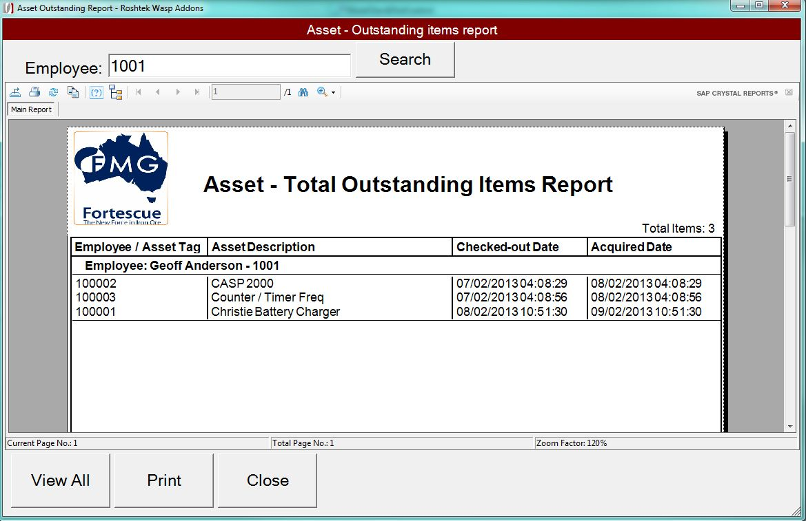

* **Click** ***Print button to* print *report.***